1. Write 8-Queens Problem

Aim: To solve 8-queens problem using python code

Procedure:

- Represent the chessboard as an 8×8 matrix.
- Place queens one column at a time.
- Check if placing a queen is safe by verifying the row and both diagonals.
- If safe, place the queen and move to the next column.
- If no safe position exists, backtrack and try another row.
- Continue until all 8 queens are placed successfully.

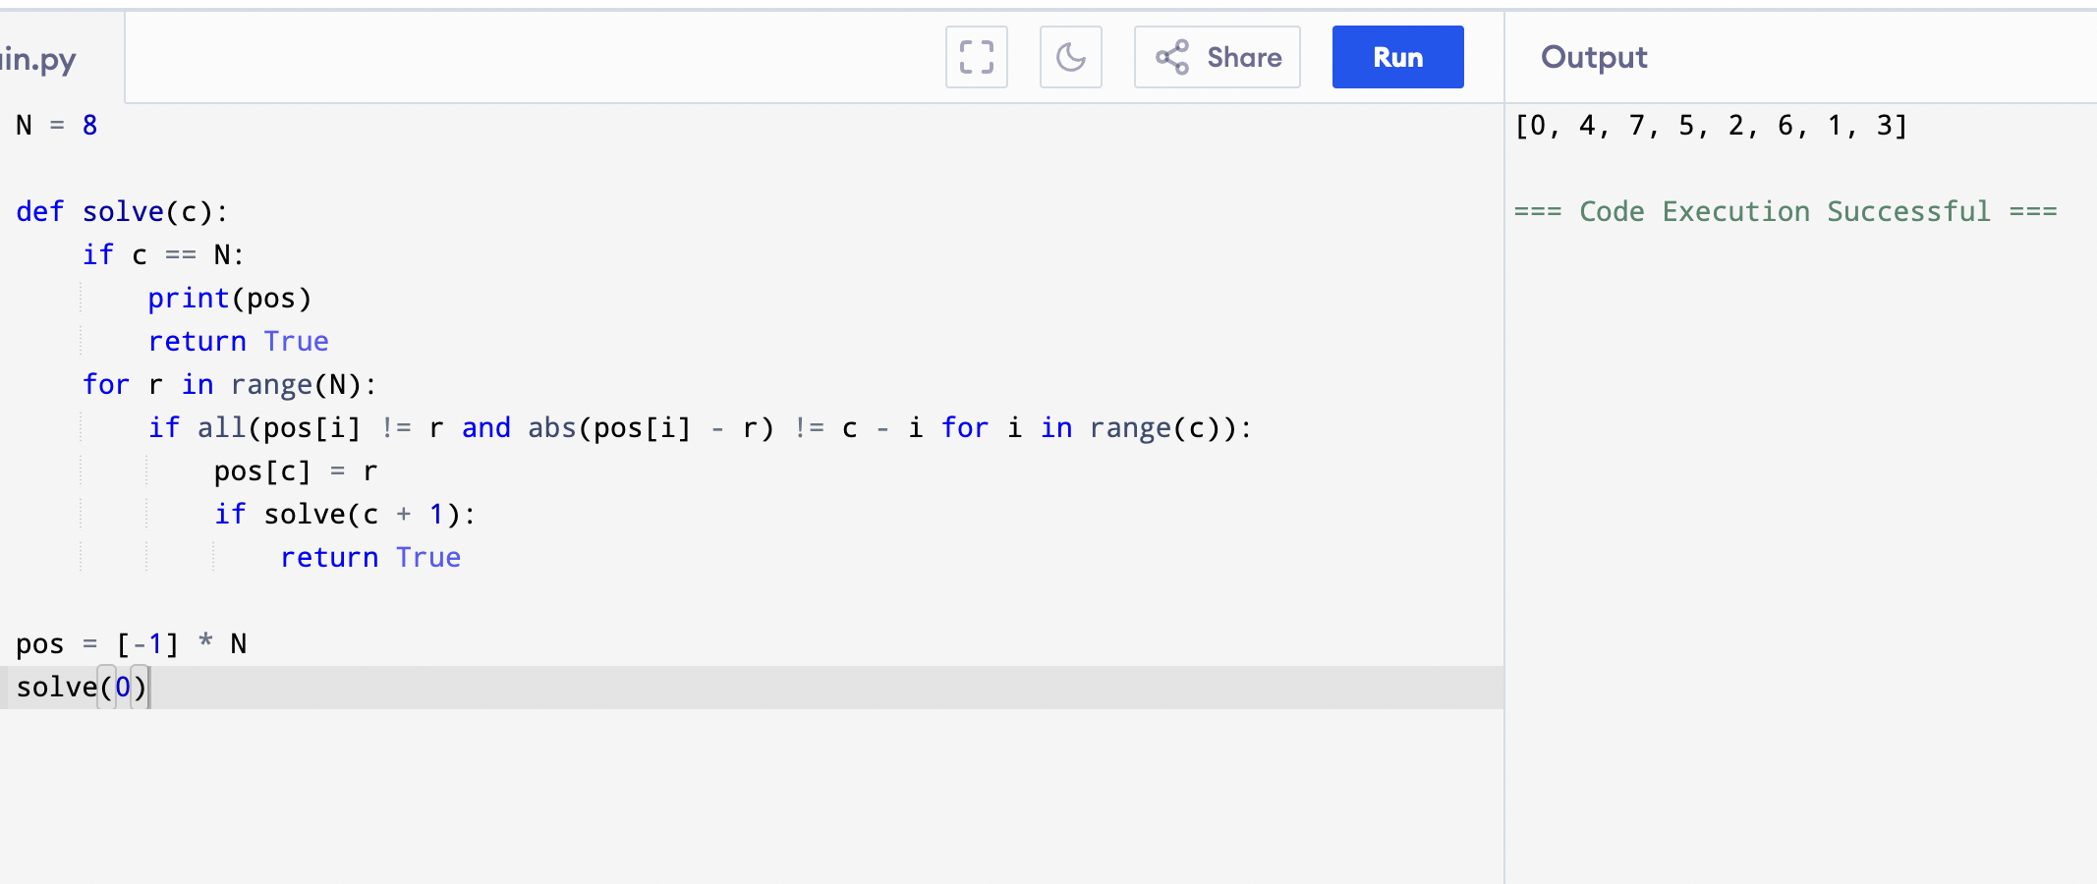
Output:

Result: Hence, the 8 queens problem has solved

